Epoch Results – 13 May 2023 – 3000 results.

Really proud of the smooth curve for the loss function.

**Results – 14 Mar 2023:**

500 epoch, atol = 0.1, rtol = 0.01, eta = 0.25

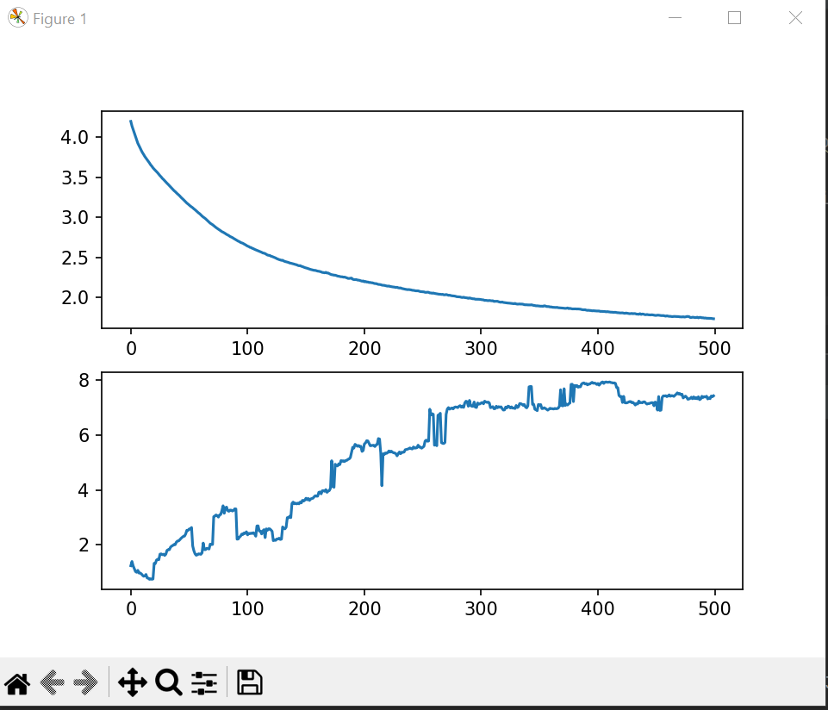

**Results**: 14 Mar 2023:

**Hyper parameters:**

Epoch: 5000, activation=sigmoid, Loss/cost function = Standard Deviation,

atol = 0.1, rtol = 0.01, eta = 0.25

**Summary**: No significant improvement with increasing epochs, may be absolute tolerance is still too low.

Results 14/3/2023:

Same params as above, but atol has been increased to 0.2.

We are able to see much improvement.

**Result**: 15 Mar 2023

There is lot of improvement, when the evaluation criteria is changed to include argmax of the output.

Epoch: 500, activation=sigmoid, Loss/cost function = Standard Deviation,

atol = 0.2, rtol = 0.01, eta = 0.25

**Results**: 15 Mar 2023

**Epoch**: 1000, activation=sigmoid, Loss/cost function = Standard Deviation,

atol = 0.2, rtol = 0.01, eta = 0.25

Better results with thousand epochs than 500, also the results curve is becoming smooth.

Report 15 Mar 23

**Epoch**: 1000, activation=sigmoid, Loss/cost function = Standard Deviation,

atol = 0.2, rtol = 0.01, eta = 0.25

Hidden Layer neurons – 10.

Summary: There is something seriously wrong with the curve. Why does the curve drop steeply only till the epoch no 20-30, and then it stops going down rapidly but just flattens out. This means, that loss function does not decrease or becomes stable after some point – why is this happening?

Result 15 Mar 2023

**Epoch**: 1000, activation=sigmoid, Loss/cost function = Standard Deviation,

atol = 0.2, rtol = 0.01, eta = 0.25

Hidden Layer neurons – 30.

We see improvement in results. Why don’t we increase hidden layer neurons to 100?

Result: 15 Mart 2023

**Epoch**: 1000, activation=sigmoid, Loss/cost function = Standard Deviation,

atol = 0.2, rtol = 0.01, eta = 0.25

Hidden Layer neurons – 100.

What is the difference, where are we going?

